SAM RAINWATER

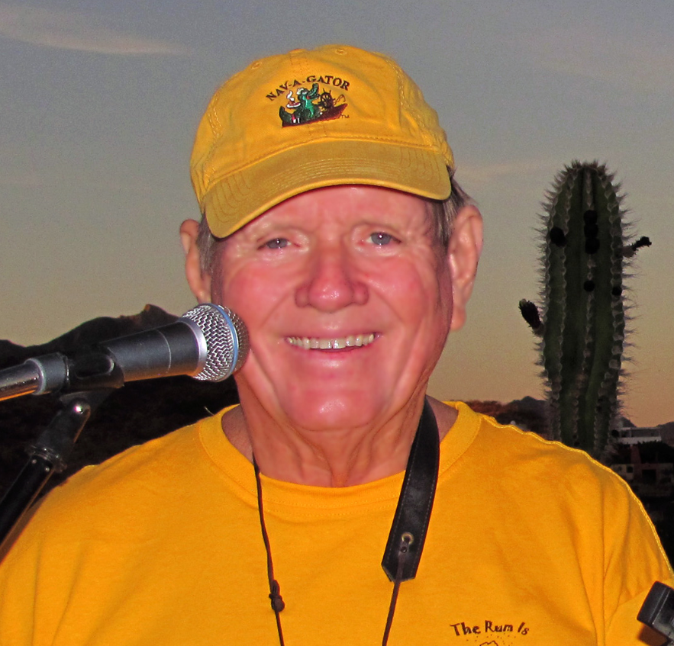
Trop Rock Award Winner & Nominee, Sam Rainwater performs an eclectic blend of “Mexatropaholic” and Trop Rock (Tropical Rock) Music. A "Rocket Scientist" in his day job, Sam is a Trop-Rocker in his soul, writing and playing music in the US and Mexico. You may have seen Sam playing or sitting in on ukulele at Trop-Rock venues and events across the country. Sam’s musical growth has taken him from being “the Uke Guy” at local Parrot Head events to the Nashville recording of his Five CD’s, “Vacation Location”, “Dressing For Life”, “Can You Not Hear Me Now” “Cheaper Than Ice” and “Have Fun Faster”.

Sam’s charitable work earned him the 2012 TRMA “I Can” Award for community service. Sam writes and plays all of his music with a purpose, donating 100% of his music income to charity and then doubling those donations through a match from his consulting company SunTronics Inc.! His current charities are various Troop efforts (while in the USA) and Castaway Kids (while in Mexico). To Date Sam has donated over $200,000 from his music.

Sam’s 1st Nashville produced album “Vacation Location” was key in Sam being nominated for the Trop Rock Horizon Award in 2011. It features 17 original Trop Rock songs. Michael Lopez of the Phoenix New Times says “this album screams Parrot Head, and the music sure as hell didn't disappoint”.

Sam’s 2nd album “Dressing for Life” continues his musical adventures. Coupled with his 1st album and charitable work, Sam’s national reputation has grown and earned him invitations to regional events and air play on internet Trop Rock stations.

Sam’s 3rd album “Can You Not Hear Me Now” is produced to showcase Sam’s talents as a Trop Rock Singer/Songwriter. It has been highly acclaimed with 2 songs in the Beach Front Radio Top 20 for 2013.

Sam’s 4th album “Cheaper Than Ice” continues Sam’s tradition of an ‘Eclectic’ Music Mix with the Title Song Cheaper Than Ice.

Sam’s 5th album “Have Fun Faster” is a travel log of Sam’s adventures in the last few years, song’s abut places & People in San Carlos, Sonora Mexico.

Sam loves to play for live audiences and welcomes invitations to play at House Concerts and “Beach Friendly” Bars and Venues across the country – all for charity! He plays his original music and cover songs that have a “beach/tropical” flavor. If you are looking for a fun Happy Hour/ Beach Themed Event, Sam is your guy!

More about Sam at www.samlrainwater.com/music.htm.

